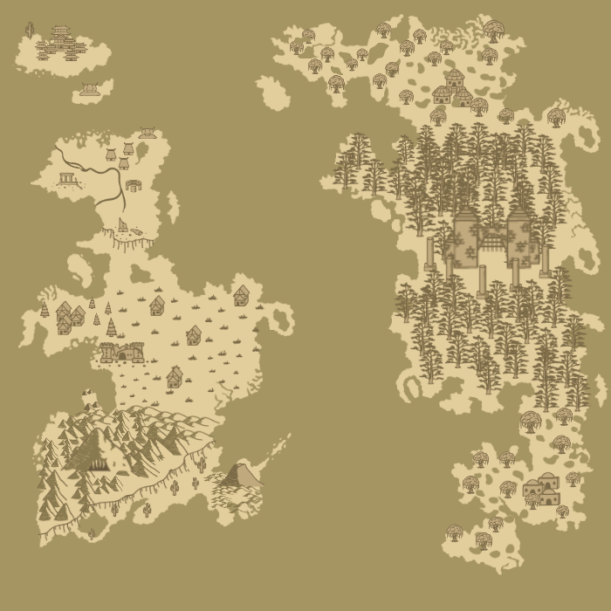

THE LAND OF AZEHRILL

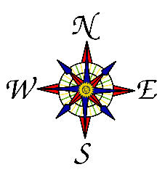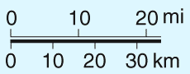

**SkyFair**

**Bright Haven**

**Axenstone**

**Banner Rock**

**Solaris Mons Valley**

**IvyWood**

**Hollow**

**Ivywood Marsh**

**South Ivywood**

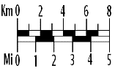

[This Photo](http://commons.wikimedia.org/wiki/File:Map_scale_-_8km,_5mi.png) by Unknown Author is licensed under [CC BY-SA](https://creativecommons.org/licenses/by-sa/3.0/)



**9**

**8**

**7**

**6**

**5**

**4**

**3**

**2**

**1**

Skyfair

1. Temple Va’las – Where the Skylurkers gather to learn the   
   wisdom of The Va’las, as well as where the King resides.

People of Interest:

- The Va’las

- Shizi Tsu’ra

- Ikric Ari

2. The River Herb – A shop run by the Kaju family.  
 People of Interest:

- Nius Kaju

- Lin’a Kaju

3. Grand Cactus – A gift to the Skylurkers from the Sun Monks in   
 Solaris Mons Valley. A giant cactus where events held.   
 People of Interest:

- Narial Ga’bal (After tutorial)

4. Raizerg’s Forge – A forge attached to The River Herb in which weapons are made and  
 sold  
 People of Interest:

- Raizerg Kaju

5. Abandoned Hut – no one has lived here in 100 years, except for ghosts, of course.   
 People of Interest:

- The ghost of Krat

6. Reverie Athenium A library full of historical books on Azehrill.:   
 People of Interest:

- The ghost of Bal’ack  
 - Ivaax

7. The Temptation – A local pub.   
 People of Interest:

- Mint

- Ghost

8. The Amber Sanctuary – Where people go to heal mentally and physically  
 People of Interest:

- Garion Ale

- Lexa Guard

9. The Nest – The entrance between Bright Haven and Skyfair   
 People of Interest:

- Narial



**8**

**4**

**3**

**2**

**1**

Bright Haven

**6**

**5**

**7**

1. The Elder Basin – The home of the Elvish monks  
 People of Interest:

- Nyvorlas

- Meira

- Orrian

2. The whistling Raven – A pub where food and drink are available.   
 People of Interest:

- Ebba

- Nineve

- Nixie Ilo

3. The Ancient Anvil – A forge in Bright Heaven   
 People of Interest:

- Seirye Zumroris

4. Ivory Isle Inn – a place for any weary traveler to rest their feet.   
 People of Interest:

- Lixiss Inarora

- Venali Chaeleth

5. Mystic Labyrinth – A mysterious place where Elvish monks are said to go to visit their relatives that have moved  
 on.   
 People of Interest:

- Zeszash

- Hexic

- Raszaa

- Azut

6. Ryre Fort – The hold has been long since abandoned by all except to large creatures of the night.

7. The Elder Pillar – Sacred prayer grounds on the Ivory Hills, separating Axenstone and Bright Haven  
 People of Interest:

- Ashryn Xyrra

- Axilya Iliwynn

- Silvyr Gillar

8. The Axis River – home to extremely dangerous creatures.